Objectives: Introduction to Email 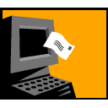

After this section on Introduction to Email you will:
- Know why email is used
- Know about similarities between email applications
- Get a free email account
- Send and receive messages

Introduction to Email

Email is electronic mail. It is similar to postal service mail, but much quicker to use. For instance, with postal service mail you write out a letter and put it inside an envelope, put a stamp on the envelope, take the envelope to a mail box and wait several days for the envelope to be delivered and read.

Email is quicker. Open your email program on a computer with a couple of mouse clicks. Click on Write. Compose a letter in the text message box. Type in the email address of your Sendee in the Send To box. Click on Send. The person receives the email nearly instantly. You just saved a lot of time and never had to find a mailbox! (Most email programs work similar to these directions, though they may have somewhat different looks.)

Email is easy to use, and it is getting very popular as a low cost way to send and receive information as well as keep in touch with people all over the world.

You do not need to own a computer to use email. You do need access to one, however. Any computer that has an Internet connection is okay. You will need an email account. There are many free email programs that are easy to use. If you can access a computer and get on-line, you can get into your email account and send and receive email.

A Look At Various Email Programs

Netscape Communicator (free)

. 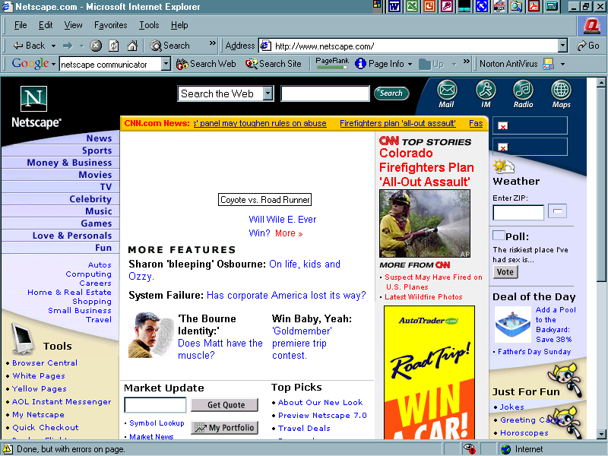

Yahoo Mail (free)
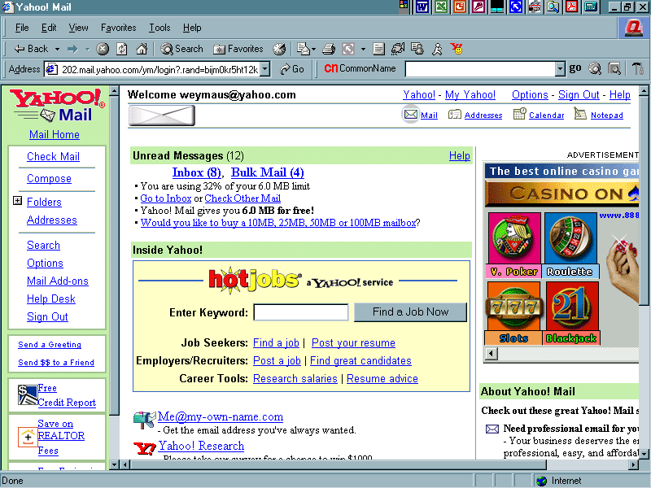

Hotmail (free)
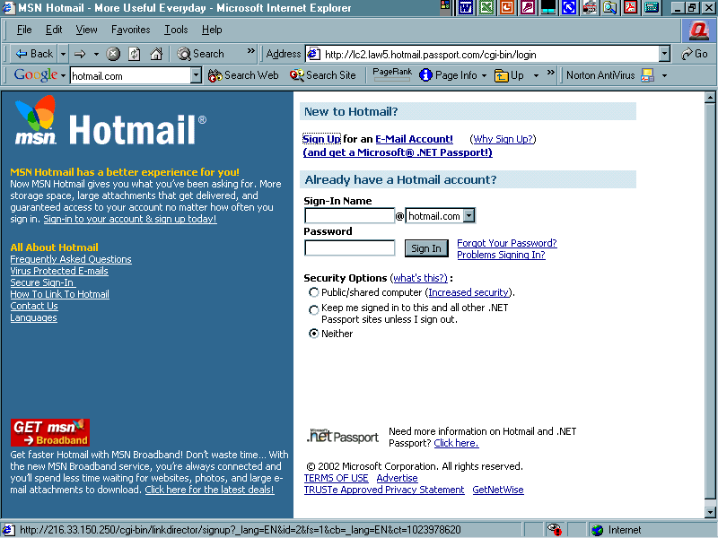

These are just a few of the many email services available. There are many more free email services to look at, also. You will probably end up using a different email service in the future after you have a chance to talk to people about their preferences. You will find features that impress you and choose an email based on what you want. Basically all email accounts ask for similar information.

Setting up an email account
After you look over the various email programs, your instructor will help you determine which email program best fits your needs.
Follow the email account set up steps with your instructor’ s assistance. (Look at a portion of the Yahoo Mail sign up form below.)
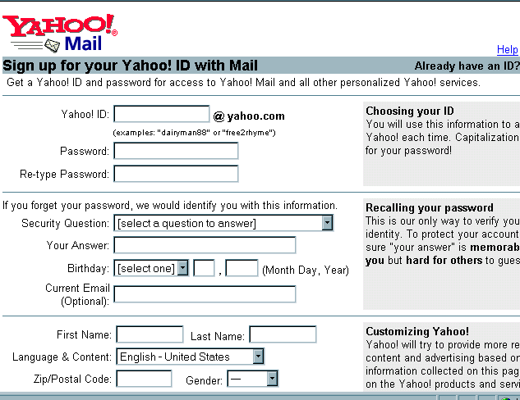
Basic email set up steps are:
Type in:
Choose a User ID (this is the email name you want to be known as)
Password and hint for password
Name first, last, etc.
Address
Birth date

Your Instructor will make suggestions regarding passwords and hints, but choose passwords that are easy to remember. Pick a word or number that you can easily recall such as a child’s name, a parent’s name, your birth date, an anniversary, etc.
Choose occupation or choose not applicable. Choose the language in which you want to read and send email.
Choose topics of interest of which you want to receive email about. Do not choose too m any, or you will be bombarded with junk email everyday.
Read the Agreement and accept terms
Some free email services require that you check your email at least once every thirty days. Read your terms and ask for help if you do not understand them.
Email addresses look like this: mbrown@yahoo.com . The first part of this email is the user ID name, mbrown. The second part is the domain name ,where the user computer is located. The symbol “@” means “at”. It is produced by holding down the shift key on the keyboard while also pressing the number 2 key.

To Send a Message
- Access the Internet
- Type the URL for your mail service in the address box (i.e. www.Yahoomail.com)
- Log on to your email account
- Type in your password.
- Click on the login button.
- You will be at your Inbox area. If mail is new, it will appear in very deep, blue type. Usually there will be Sender name, subject and date it was sent.
- See the picture below for a look at the Yahoo Mail inbox.
Email address

Commands to write or compose email on various email services will look different, but function the same. For instance, In Yahoo email the command to write an email will be “Compose” In Outlook, it will be “New”, In America Online it will be “Write”. All of the email services indicate the following regarding sending email out:
TO
FROM
SUBJECT

Cc: (carbon copy)
Bcc: (blind carbon copy) THESE ITEMS WILL NOT BE USED IN THE LESSONS

When sending email it is very important to type the address completely and correctly. Make sure you always include the @domainname.com. The most frequently used domain names are: com, org, gov, net, and sometimes country abbreviations such as UK (Britain).

If email addresses are incorrect, they will not be delivered and the sender will receive a message saying something like” undeliverable”, “Message has not been sent,” “check address,” “an error has occurred”. Various email services will advise the sender that the email has not been successfully delivered. When this happens, check to make sure the email address you are using has no spaces, contains the @, and has a dot (.) For example: mbrown@yahoo.com . If the email still does not go through, check with the recipient for the correct address. People do change their email service or web browsers occasionally. It is similar to moving one’s place of residence and having the mailing address changed.

Use the email log on the following page to keep track of email addresses

(Example)
Name | Email Address | Subject / website
Joe Brown | jbrown@yahoo.com | brother
Ann Smith | asmith@cd@netscape.org | PCA , www.cityhosp.org

Examples of incomplete or incorrect emails:

J brown @ yahoo . com Do not put spaces in email address

Jbrownyahoo.com There is no @

jbrown@ There is no domain name

jbrown@yahoo.com CORRECT!

Email address log

(Add names, email addresses and what they are about so you have easy access to the information. It easy to forget an email address!)

Name | Email Address | Subject / website

See the picture below for a look at the “Compose” section of Yahoo Mail.

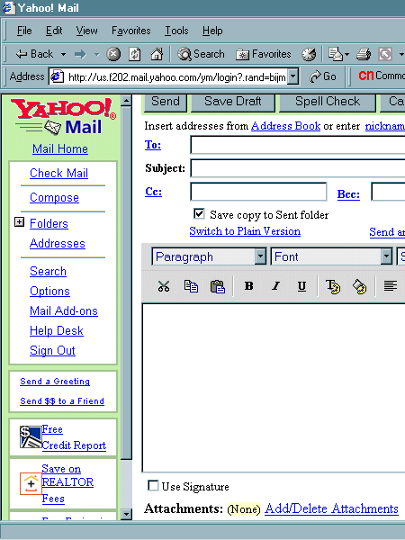

Write your message here

Include a subject. This makes it easier for the recipient to skim through emails, and keeps a string of emails of this subject together for writer and recipient.

Write a message. Click on spell check if you want to fix spelling errors. Click on Save Draft if you want to save the message until a later time to send it. Click on Send if you are ready to send out the email.
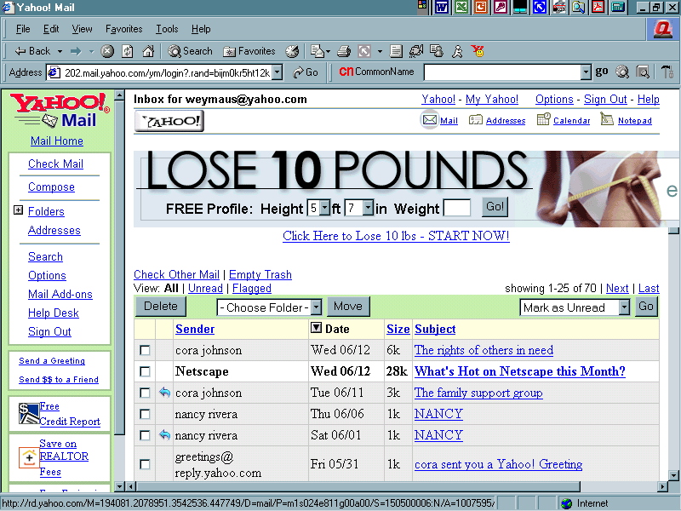
Click on the Check Mail command to see your email list. The sender, date of delivery and subject is shown. To read the individual email messages, click on the bold (unread) text. Text that is normal color is email that has been opened before.

Reply to email you receive by clicking on the Reply button. Keep the subject the same or make any changes, especially if you are adding new information. It is ok to change a topic now and then. It makes the email interesting to read and indicates a different topic is the focus.

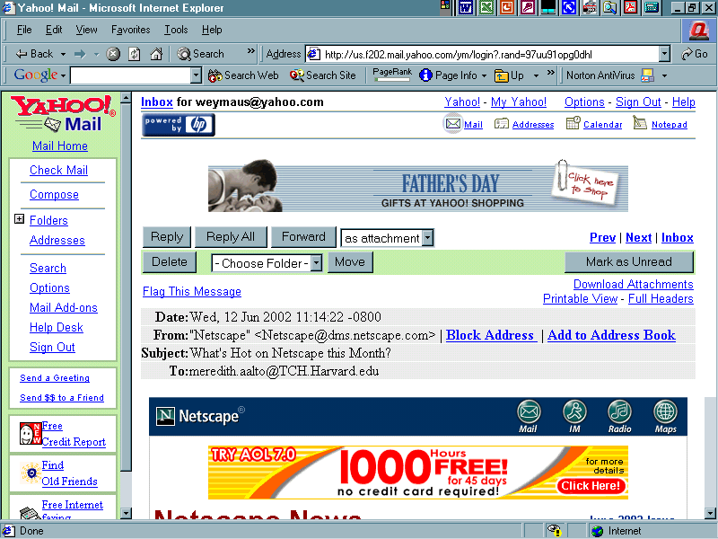

Exercise 1
Students will exchange their email addresses with each other.
- Close out of all windows until you are at the Desktop.
- Access the Internet by clicking on the Internet icon.
- Type in the URL of your email service in the address box.
- Click on the command to write an email.
- Fill in the TO, SUBJECT lines.
- Send the email.

Exercise 2
- Click on the Check Mail command.
- Click on various email lines.
- Read messages.
- Click on Reply. Reply to senders by writing new message responses.
- Complete three replies to emails.
Any questions? Email me at: Meredith.aalto@umb.edu

Exercise 3
Students will visit websites that provide disability related information. Where a contact email is provided students will write a message or ask for information. The instructor will help you.

Bonus Lesson

Sending Attachments/Opening attachments: Some computers used in this training and at certain public stations do not allow students to use the attachment feature. The instructor will help you determine if this feature is available.

To send an attachment, write the email message as done so above. Click on the attachment command. This is usually a picture of a paperclip,  but may also say ATTACH. A box opens that will allow you to search any drive or folder on the computer to locate the document you want to send. Locate the folder, then the document file you want to attach and send. Comnds will vary, but typically you will click on the document file. Click the Attach this File Command. Click Done. Click Send.

To Open an attachment in an email, Click on the line that indicates an attachment. It will open or say Save this file to a folder. File it as you would any file. Open it in the appropriate place.

